After Hours
In case of emergency, please call 000 immediately.
Royal North Shore Hospital Emergency Department, located on Reserve Road St Leonards, please call 9926 7111.
Sabrina saldanha : 0417 427 337 Interpreter number: 131 450

Pathology

We use Douglas Hanly Moir as our in-house pathology collectors. Please make a follow-up appointment with your doctor when you have had your pathology test. Results will not be given over the phone or to family members. Copies of pathology results must be requested from your doctor during your consultation.
Pathology Hours:
Monday to Friday 8.00am to 4.00pm
Satur day 8.30am to 12.00pm

Transfer of Medical Records Upon written request from your new doctor, with your consent signature, your Health Summary Records will be transferred directly to our practice. A request form for copies of your files must be signed by the patient.
A minimal fee of $ 55 applies to this service.
It’s a Matter of Time! Despite our best intentions, we sometimes run late. This is because someone needs unexpected urgent attention, has a challenging health issue, or we are handling a medical emergency.
Be assured that when it comes to your consultation,
the doctor will give your health issue the time it deserves.

Covid Vaccinations
We are offering Pfizer in our clinics. Please go to our website and to your Hotdoc site to book appointments online.

Feedback, Suggestions & Evaluation The practice welcomes your feedback and suggestions. We have a suggestion box available in the receptionist area or you can speak with your doctor or a reception staff member.
Patients are invited to complete a survey from time to time to assist the practice in improving its service.

Complaints
If you have any concerns about the service, you have been provided at the practice, please speak with our Practice Principal Dr Saldanha or you can send a letter to the practice.
Should you be unable to resolve your concerns with our Practice Principal, you can contact the NSW Health Care Complaints Commission:
Tel: 02 9219 7444 or Toll-Free 1800 043 159
Level 13, 323 Castlereagh Street Sydney NSW 2000 Our Team of Wonderful Doctors As this practice has been established in the local area for over 20 years, we are proud to have long-term doctors at the practice. The special interests of the doctors in this practice include paediatrics, obstetrics, women and men’s health, sexual health, mental health, dermatology, and sports medicine.
Dr Sabrina Saldanha Dr Celine Holland
Dr Eric Barlow Dr Lisa Hurrell
Dr Sunny Misir Dr Nerida Holdaway
Dr Asher Hiddlestone Dr Brijinder Randhawa
Dr Vanessa Ricketts
Our Experienced Administration Team We are very sorry to say goodbye to Marelyn, Doris and our Nurse Natasha who left us and have chosen to move forward in their careers.
We welcome our new receptionists, Stephanie Kucukakca , Rheah Menon, Natalie Tovar, and Katarina Parangi-Lualua.
We also welcome our new practice nurse, Cassandra and nurse Daria.

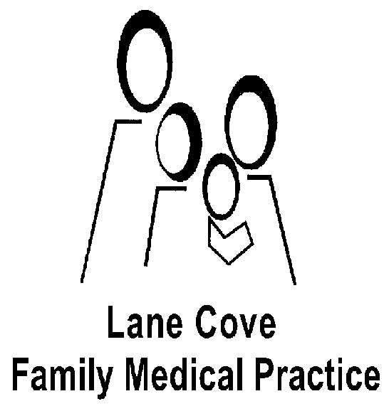

Practice
Information
Dear Patient,

On behalf of the doctors and staff, we would like to take a moment to welcome you and your family to our practice.

As a new patient to this practice, you may find this information useful as an introduction to our facilities and practice procedures.

Our staff are always available and happy to answer any further queries you may have regarding any of our services.

We are committed to caring for your health and, once again, appreciate you placing your health care in our hands and your affiliation with Lane Cove Family Medical Practice.

Please log on to our website for more information on our practice. You can also book appointments online on www.lcfmp.com.au.

Medicine today is about continuity of care and we look forward to an ongoing association with you and your family.

Yours in Good Health,

Dr Sabrina Saldanha
Practice Principal
47 Tambourine Bay Road Lane Cove NSW 2066 tel. 9427 7622 fax. 9427 7120 web. www.lcfmp.com.au

While our staff is happy to assist you over the phone, we are unable to support email communication at this stage.

Sequin Crest Pty Ltd trading as Lane Cove Family Medical Practice
ABN 85 007 041 876

The Practice
We are proudly accredited by Australian General Practice Accreditation Limited (AGPAL). This award acknowledges the high quality of our medical practice. AGPAL Surveyors consider many aspects of General Practice using standards set by the Royal Australian College of General Practitioners (RACGP). To achieve accreditation, it is necessary that the practice provide quality, comprehensive and continuing care to patients in a caring environment.
Patients can be reassured that our practice ensures their health, their rights, and their needs are our top priority.
Our Services
Covid and flu vaccinations
Antenatal Shared Care
Baby Checks
Cardiographs and Heart Checks
Care Plans (patients with chronic illnesses)
Childhood Vaccinations
Counselling and Mental Health Checks
Cryotherapy (liquid nitrogen)
Employment, Life Insurance Reports
Family Planning
Flu Vaccinations ‘Head to Toe’ Annual Checkups
Health Assessments for patients 45 yrs, +75 years
Holter Monitors
Minor Surgery (disposable instruments)
Cervical Screening (every 2 years)
Pregnancy Tests
Removal of Lesions Suturing Cuts
Travel Vaccinations
In-house Pathology
Many of these services require a long appointment to provide adequate time for your doctor to conduct a thorough check and discuss any issues or concerns you may have.
At the time of booking your appointment, please let our receptionists know if you have several issues to discuss. They can allocate adequate time for your appointment.
Booking Appointments, You can now book appointments online at www.lcfmp.com.au
If you need a postnatal check, removal of lesions, insurance medical, health check, review of a complex health issue, or counselling, please request a long appointment.
If you are unable to attend your appointment, please contact the practice with 12 hours’ notice to cancel or reschedule your appointment as a non-attendance fee may be charged.
Covid vaccinations can also be booked via the link above.
Consulting Hours
Monday to Friday 8.30 am to 5.30 pm
Saturday 8.30am to 12.30pm

Consultation Charges
We are a private billing practice.
All consultations are to be paid on the day of your appointment.
Standard Consultation/ TELE $85.00
Level B: appointment up to 15 minutes
Out of pocket 45.25 Medicare Rebate $39.75

Long Consultation $145.00
Level C: appointment up to 30 minutes
Out of pocket $68.05 Medicare Rebate $76.95

Prolonged Consultation $190.00
Level D: appointment 40+ minutes
Out of pocket $76.70. Medicare Rebate $113.30
Standard Telehealth $85.00
Babies not yet registered with Medicare will be privately billed. When your Medicare card has been updated, you can then claim your rebate.
All Work Cover appointments are privately billed and payable on the day of your consultation. You can provide your employer or insurance company with your receipt for reimbursement. Additional charges apply for consumables such as dressings, glue, and chargeable vaccines. Bulk Billing
Children are bulk billed until their 5th Birthday with a valid Medicare Card. Valid Pension Card Holders and Department of Veterans Affairs Card Holders are bulk billed.
Please note, all Saturday appointments will be charged privately and not bulk billed.

Reminder System
Our practice is committed to preventative care. Unless you notify us otherwise, we may issue you with a reminder notice offering you preventative health services appropriate to your care. Patient confidentiality is always maintained.
Referrals, Prescriptions, and Test Referrals In the interest of your medical care, the doctor needs to see you for these services. We are unable to backdate medical certificates and referrals.
Doctors in this practice are competent at handling all the common health problems. When necessary, they can draw on opinions from Specialists, and if need be, refer you for further investigation. Each doctor is free to choose the consultant or service of their choice and you can discuss this openly with your doctor.
For reasons of confidentiality:
No results will be faxed or emailed to the patient or relatives. If need be, the results will be faxed to the specialist or on doctors’ approval.
Email confidentiality: results/referrals will be emailed to the specialist upon request. Other results and referrals need to be approved by the treating doctors in certain circumstances. To provide best care to our patients we do not answer clinical questions via email. Please call us.
Telehealth: these are only available to patients who have been seen at the practice in the last 12 months, all telehealth is billed as per billing policy.
Test Results (Pathology, X-Ray Results, PAP tests) For medico-legal reasons, and in the interest of strict confidentiality of your medical records, no test results will be given to patients over the phone, faxed, or to family members. Patients are requested to make an appointment to be reviewed 2–7 days after the test to explain the results.
If the results are of a serious nature, the patient will be contacted immediately.

Telephoning your doctor
A doctor will always be available during normal surgery hours for emergency advice.
Our staff are experienced in helping you decide whether the matter requires an appointment or advice over the phone.
Home Visits
Home visits are available on request for existing patients of the practice with prior arrangements.
Please call the surgery first thing in the morning to discuss.
Home visits apply to the local area only and these visits are billed privately and not bulk billed.

